Table of Contents
1. Introduction 3
1.1 Purpose 3
1.2 Scope 3
2. Requirement Analysis and Specification (RAS) 3
2.1 System Boundaries 3
2.2 Stakeholders 4
2.3 External Actors 4
2.4 Analysis of Phenomena 4
2.5 Domain Assumptions (D) and Goals (G) 5
3. Use cases 5
3.1 Use case diagram 5
3.2 Use Case 1: 6
3.3 Use Case 2: 6
3.4 Use Case 3: 7
3.5 Use Case 4: 7
4. Class diagram 8
5. Requirements 8
5.1 Functional Requirements 8
5.2 Non-Functional Requirements 9
5.3 Technical Requirements and Constraints 9

- Introduction

1.1 Purpose
The purpose of this document is to define the requirements for a client-server application that supports city-level heat monitoring for Milan (Italy) and Mexico City (Mexico). It describes the system boundaries, identifies external actors and relevant phenomena, specifies functional and non-functional requirements, and defines the use cases that guide the system's development. This document serves as the foundation for the subsequent Design Document (DD) and Software Release Document (SRD).

1.2 Scope
The scope of this project is to develop a client-server application to support city-level heat monitoring for the urban areas of Milan (Italy) and Mexico City (Mexico). The system will specifically monitor and analyse three key meteorological parameters: Temperature, Relative Humidity, and Precipitation. By integrating these geographically explicit measurements, the system allows decision-makers to understand heat-related stress and urban climate trends.

Requirement Analysis and Specification (RAS)
2.1 System Boundaries
Defines what is inside the scope of development and what exists as part of the external environment.
- The Machine (Inside Boundary):
  - the PostgreSQL/PostGIS database for storage,
  - the Flask web server (backend) for processing and REST API management,
  - the Jupyter Notebook dashboard (client) for visualization (maps, graphs and statistical descriptor).

- The World (Outside Boundary):
  - the Meteostat API infrastructure provided via RapidAPI.
  - The acquisition and upload of the data by the Meteostat API.
  - the physical weather stations and event,
  - the end-users (local decision-makers) who interpret the output.

- The Interaction:
  - The machine interacts with the world by sending requests to Meteostat and receiving meteorological data (temperature, humidity, and precipitation) in JSON format.
  - The user is querying data to the web server.
  - The user requests a notification service for future extreme weather events.

2.2 Stakeholders
- Public Authorities (Comune di Milano, Mexico City Government): Commission the system and use its output to monitor urban heat conditions and issue advisories.
- Urban Planners: Use the system's reports and maps to make decisions about infrastructure, green spaces, and building regulations.
- Civil Protection Agencies: Benefit from heat stress alerts to coordinate emergency responses.
- Researchers and Scientists: Use the historical data and trend analysis for climate studies and academic publications.
- Citizens: Indirect beneficiaries - decisions made using this system affect their daily lives, health, and comfort.
- Development Team: Designers, programmers, and testers who must understand the requirements to build the system.

2.3 External Actors
- Dashboard User: Human actor who opens the Jupyter Notebook dashboard, selects a city, parameter, and time range, visualizes maps and charts, and configures alert thresholds.
- Meteostat API (via RapidAPI): External system actor that receives HTTP requests from the backend and returns historical hourly observations and station metadata in JSON format.
- Map Provider (OpenStreetMap / Folium): External service that provides geographic base map tiles rendered by the dashboard.

2.4 Analysis of Phenomena
Phenomena are categorized based on whether they are controlled by the world, the machine, or shared between them.
- World Phenomena: these are events occurring in the real world that the machine cannot directly observe or control.
  - Urban Heat Events: Physical rising temperatures and heat-related stress in the urban environments of Milan and Mexico City.
  - Physical Sensor Measurements: The actual recording of temperature, humidity, and rainfall by physical weather station hardware.
  - Pollution and climate change: Weather can change depending on external conditions in cities
- Shared Phenomena: these represent the "interface" where the world and machine meet.
  - API Requests (Machine Controlled): The backend server initiates a request to Meteostat using a specific RapidAPI key.
  - Data Retrieval (World Controlled): Meteostat provides hourly observations of temperature (temp), humidity (rhum), and precipitation (prcp) in JSON format.
  - User Parameters (World Controlled): The user selects a specific city (Milan or Mexico City) and a time range on the dashboard.
  - Data Availability and Quality (World Controlled): Meteostat data is corrupted by outdated records of weather stations due to local data provider
- Machine Phenomena: these events occur entirely inside the developed software.
  - Data Cleaning: The Flask server performs preprocessing and cleaning on the raw JSON data received from the API.
  - Database Record Storage: The system creates and updates SQL entries in the database to store station metadata and observations.
  - Dashboard Visualization: The generation of interactive charts and map-based views using libraries like Plotly or Folium.

2.5 Domain Assumptions (D) and Goals (G)
The success of the requirements (R) depends on the validity of domain assumptions.
- Goal (G): To provide geographically explicit measurements to help planners understand and respond to the effects of rising temperatures.
- Domain Assumption (D): Meteostat provides reliable and accurate weather-station data for the selected geographic coordinates.
- Requirement (R): The system shall retrieve, store, and visualize historical hourly observations for at least two weather data types (Temperature, Humidity, and Precipitation) for Milan and Mexico City.
- Use cases

3.1 Use case diagram
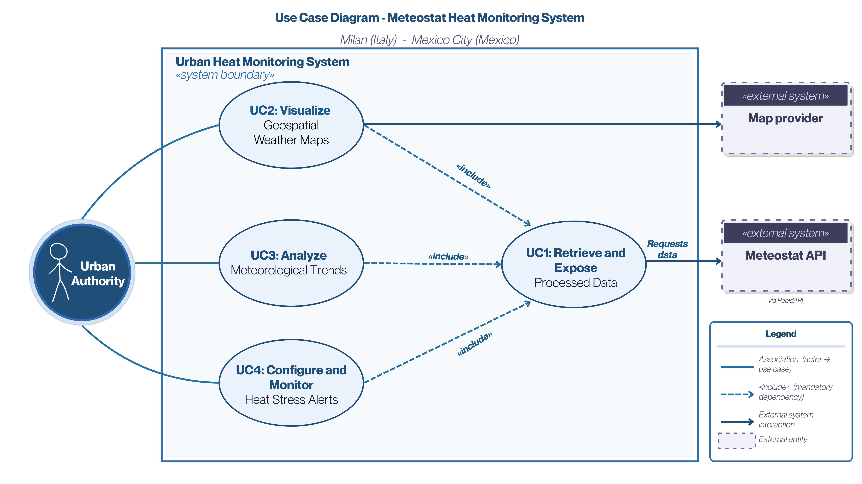
Figure 1. Use case diagram showing how the Urban Authority interacts with the system to retrieve data, visualize maps, analyze trends, and configure heat stress alerts using Meteostat API and map provider services.

3.2 Use Case 1:
- Name: Retrieve and Expose Processed Data.
- Participating Actors: Urban Authority (Human), Meteostat API (System).
- Entry Condition: The Web Server (Flask) receives a REST request from the Dashboard for specific weather parameters for Milan or Mexico City.
- Flow of Events:
  - The Machine checks the local PostgreSQL database for the requested hourly observations.
  - If the data is missing or incomplete, the Machine sends a request to the Meteostat API via RapidAPI.
  - The Machine receives the raw data in JSON format.
  - The Machine performs data cleaning and preprocessing to handle missing values or incorrect formats.
  - The Machine stores the cleaned meteorological records (temp, rhum, prcp) and station metadata into the database.
- Exit Condition: The Web Server returns a structured JSON dataset to the Dashboard.
- Exceptions:
  - RapidAPI limit reached: The system informs the user that the monthly limit of 500 requests has been exceeded.
  - Network failure: The system returns an error code if the connection to Meteostat is lost.

3.3 Use Case 2:
- Name: Visualize Geospatial Weather Maps.
- Participating Actors: Urban Authority.
- Entry Condition: The User access the Jupyter Notebook dashboard and the map component is initialized.
- Flow of Events:
  - The User selects a city (e.g., Milan) and a parameter to visualize (e.g., Precipitation).
  - The Dashboard requests the necessary geospatial data from the Web Server.
  - The Machine retrieves station coordinates and weather values from the database.
  - The Machine overlays the meteorological information as an interactive layer on an OpenStreetMap base map.
  - The User inspects specific station markers to see real-time or historical values.
- Exit Condition: The User views an updated, interactive geospatial map showing the distribution of the selected parameter.
- Exceptions:
  - Basemap loading error: The system notifies the user if the map tiles cannot be loaded and displays data on a blank grid.

3.4 Use Case 3:
- Name: Analyze Meteorological Trends.
- Participating Actors: Urban Authority.
- Entry Condition: The dashboard is active and historical data for the selected city and timeframe is stored in the database.
- Flow of Events:
  - The User selects a specific timeframe (e.g., a heatwave week in Mexico City) and a parameter (e.g., Temperature).
  - The Machine queries the database for all hourly observations within that period.
  - The Machine processes the data to generate interactive line or bar charts using libraries like Plotly or Matplotlib.
  - The User interacts with the chart to compare values at different hours or stations.
- Exit Condition: The system displays the interactive charts representing the temporal trend of the selected parameters.
- Exceptions:
  - Insufficient Data: The system warns the user if there are gaps in the hourly measurements for the chosen interval.

3.5 Use Case 4:
- Name: Configure and Monitor Heat Stress Alerts.
- Participating Actors: Urban Authority.
- Entry Condition: The dashboard logic is loaded and weather data is available.
- Flow of Events:
  - The User configures a personal view by setting alert thresholds for temperature and humidity (e.g., Temp > 35°C and Humidity > 70%).
  - The Machine scans the database observations for Milan or Mexico City to find matches with the defined criteria.
  - The Machine identifies periods of extreme heat-related stress (Urban Heat Island effects).
  - The Dashboard highlights these critical events in a dedicated panel with color-coded warnings.
- Exit Condition: The system displays a list of critical weather events based on the user-defined thresholds.
- Exceptions:
  - Invalid Configuration: The system prompts the user to correct thresholds if they fall outside logical ranges (e.g., negative humidity).
- Class diagram
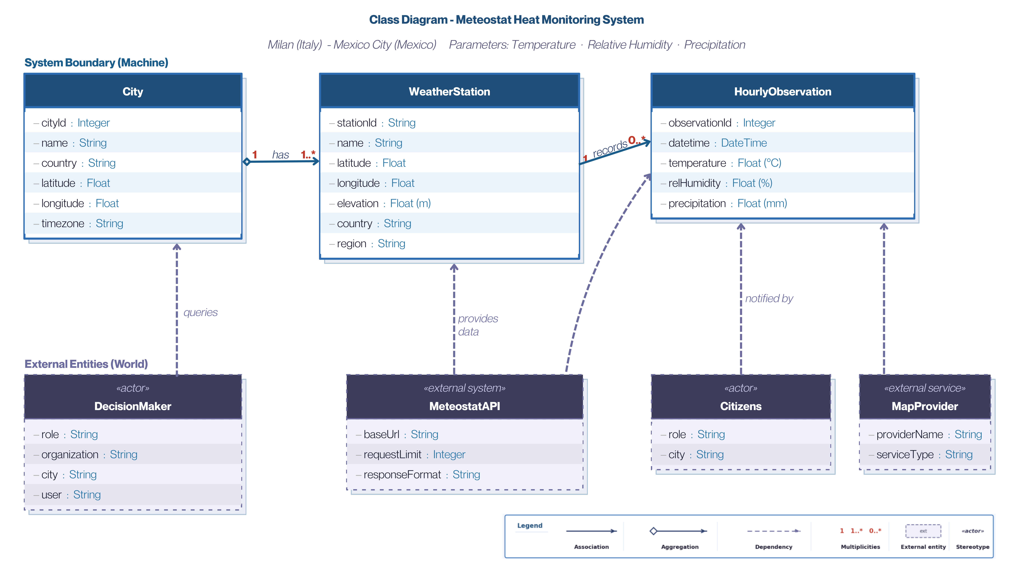
Figure 2. Class diagram showing the main system entities, including cities, weather stations, and hourly observations, as well as their relationships with external actors and services such as the decision-maker, Meteostat API, citizens, and map provider.
- Requirements

5.1 Functional Requirements
Database:
- R1: The system shall ingest and store weather station metadata (ID, name, coordinates, elevation, country, region) in a PostgreSQL/PostGIS database.
- R2: The system shall ingest and store hourly meteorological observations linked to their corresponding weather station.
- R3: The system shall support queries on stored data for further analysis and visualization.
Backend (REST API):
- R4: The system shall expose a REST API for querying the database and retrieving processed data in JSON format.
- R5: The system shall interact with the Meteostat API to retrieve hourly observations and station metadata.
- R6: The system shall perform data cleaning and preprocessing before returning results to users.
- R7: The system shall return all data to users in JSON format.
Dashboard (Jupyter Notebook):
- R8: The system shall provide map-based views displaying weather station locations and their observations using geographic content .
- R9: The system shall provide interactive graphs for analyzing weather observations.
Data Integration:
- R12: The system shall retrieve and process station-based weather data for 2 cities (Milan and Mexico City).
- R13: The system shall retrieve and process at least 2 weather data types (temperature, humidity, and precipitation).
- R14: The system shall retrieve and process station metadata from Meteostat.
- R15: The system shall combine station metadata and hourly observations into a structured dataset containing sensor metadata, hourly measurements, and geolocation.

5.2 Non-Functional Requirements
- NF1: The Meteostat API key shall not be exposed in client-side code or in the GitHub repository.
- NF2: “API Response Time” the requests sent from the Dashboard to the server for data already present in the local database must be processed and returned in less than 2 seconds under normal workload conditions.
- NF3: “Timezone Management” all hourly data stored in the database and exchanged via API must be strictly saved in UTC format to avoid inconsistencies in temporal analysis between Milan and Mexico City.
- NF4: “Localization” the Jupyter Dashboard interface (texts, widgets, and error messages) must support the English language as the international standard for scientific collaboration between the Milan and Mexico City teams.

5.3 Technical Requirements and Constraints
- T1: The backend shall be implemented in Python .
- T2: The database shall be PostgreSQL with the PostGIS extension.
- T3: The dashboard shall be built using Jupyter Notebook with interactive widgets.
- T4: The Meteostat API shall be accessed via RapidAPI
- T5: Source code and documentation shall be stored in a GitHub repository.
- T6: The system shall use open-source software only.

